**from** keras.models **import** load_model

**from** keras.preprocessing **import** image

**import** numpy **as** np

**import** cv2

**import** matplotlib.pyplot **as** plt

Using TensorFlow backend.

In [3]:

model **=** load_model('weights.hdf5')

model**.**compile(loss**=**'binary_crossentropy',

optimizer**=**'rmsprop',

metrics**=**['accuracy'])

WARNING:tensorflow:From /home/diwas/.conda/envs/tf/lib/python3.7/site-packages/tensorflow/python/framework/op_def_library.py:263: colocate_with (from tensorflow.python.framework.ops) is deprecated and will be removed in a future version.

Instructions for updating:

Colocations handled automatically by placer.

WARNING:tensorflow:From /home/diwas/.conda/envs/tf/lib/python3.7/site-packages/keras/backend/tensorflow_backend.py:3445: calling dropout (from tensorflow.python.ops.nn_ops) with keep_prob is deprecated and will be removed in a future version.

Instructions for updating:

Please use `rate` instead of `keep_prob`. Rate should be set to `rate = 1 - keep_prob`.

WARNING:tensorflow:From /home/diwas/.conda/envs/tf/lib/python3.7/site-packages/tensorflow/python/ops/math_ops.py:3066: to_int32 (from tensorflow.python.ops.math_ops) is deprecated and will be removed in a future version.

Instructions for updating:

Use tf.cast instead.

In [4]:

img **=** image**.**load_img('cancer/val/Cancer/_2_4392.jpeg', target_size**=**(150, 150))

imgplot **=** plt**.**imshow(img)

x **=** image**.**img_to_array(img)

x **=** np**.**expand_dims(x, axis**=**0)

images **=** np**.**vstack([x])

classes **=** model**.**predict_classes(images, batch_size**=**10)

**if** classes **==** [1]:

print("cancer")

**else**:

print("Normal")

cancer

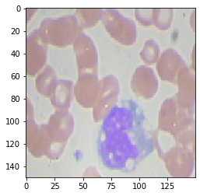

In [ ]:

In [ ]:

In [ ]:

In [ ]:

In [ ]:

In [ ]: